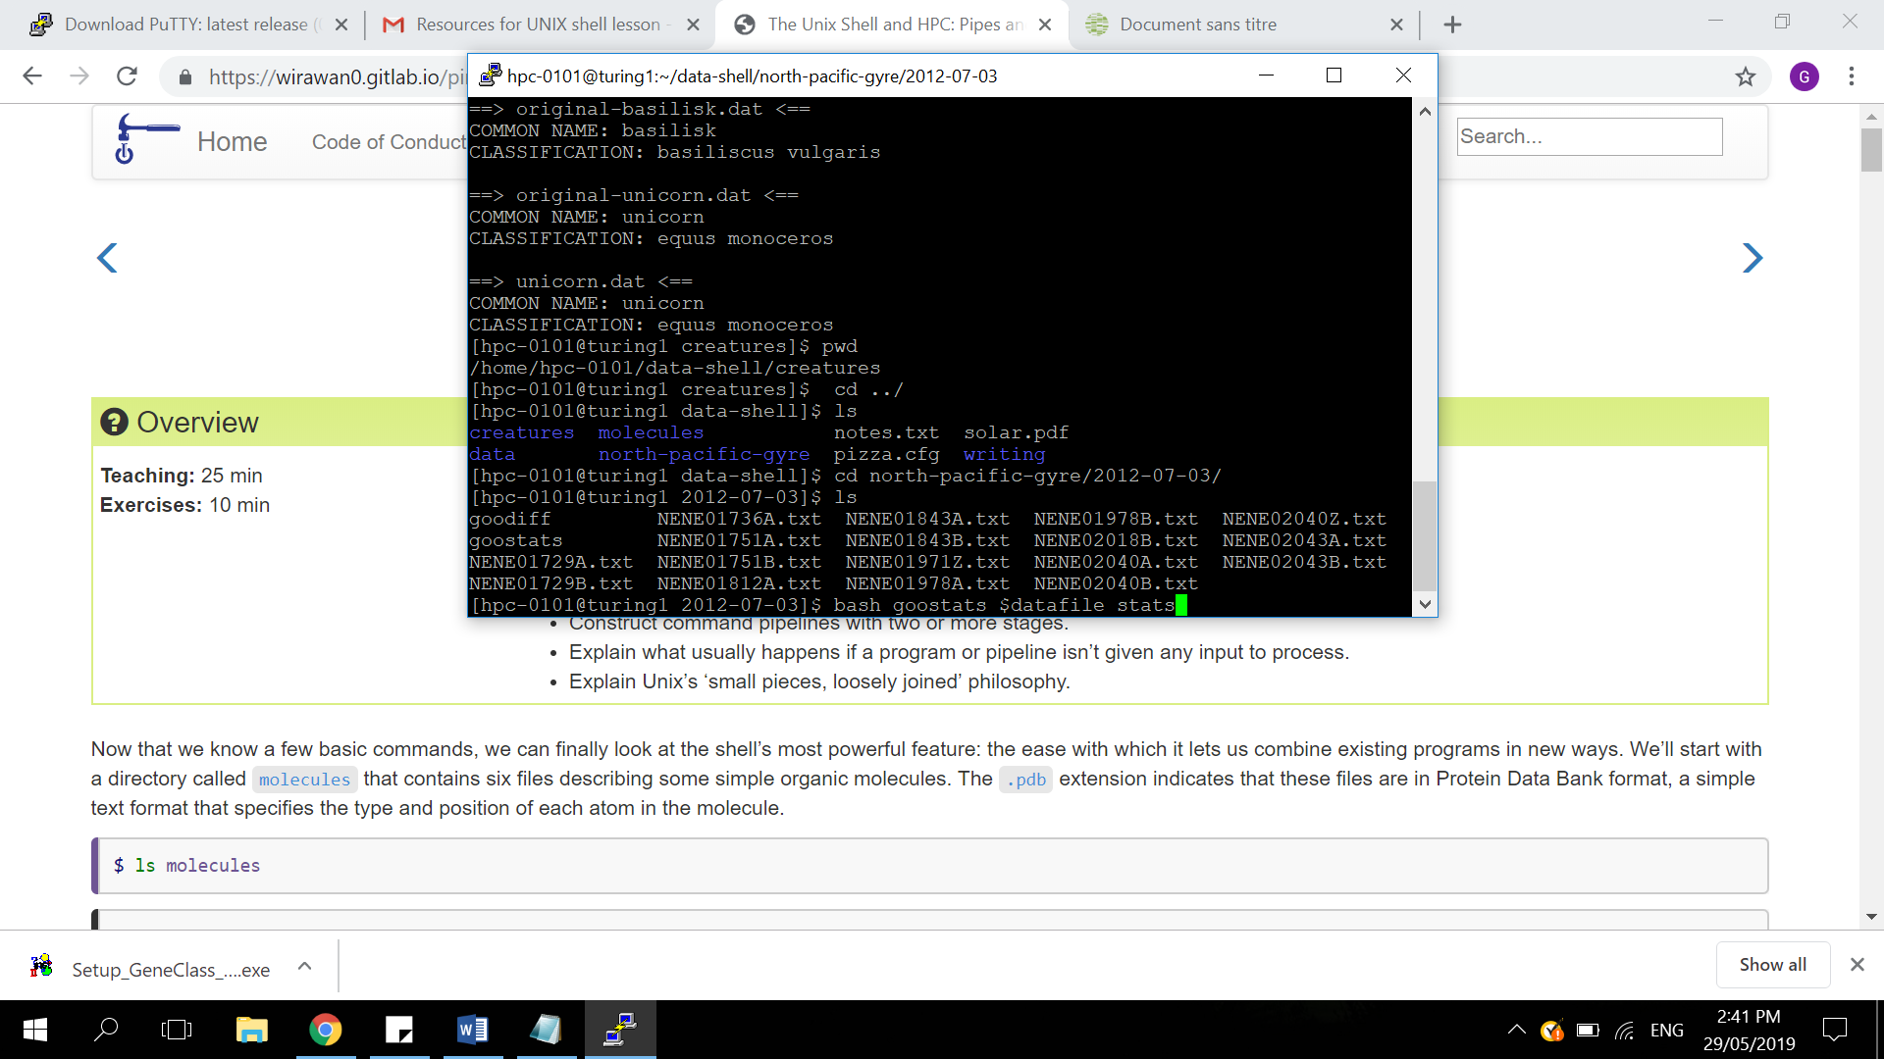

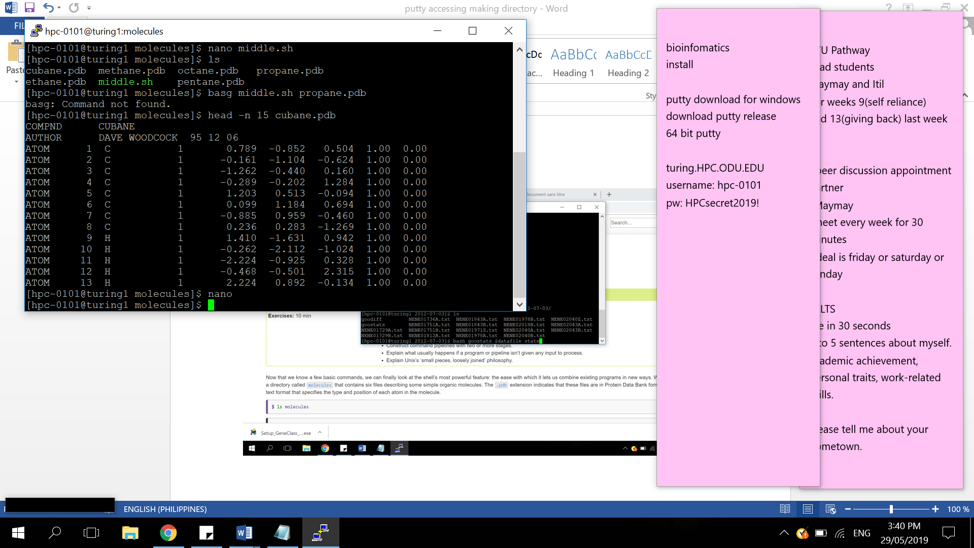

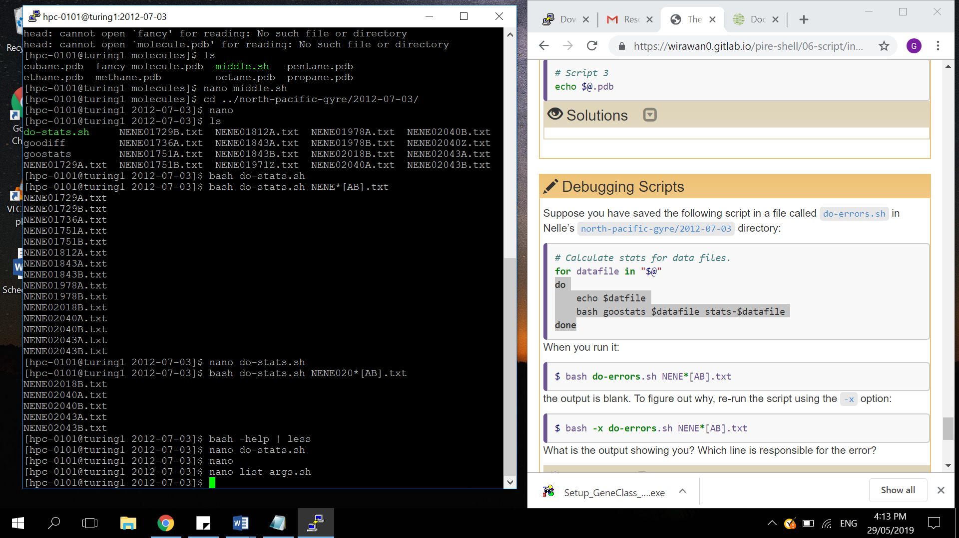

Nano

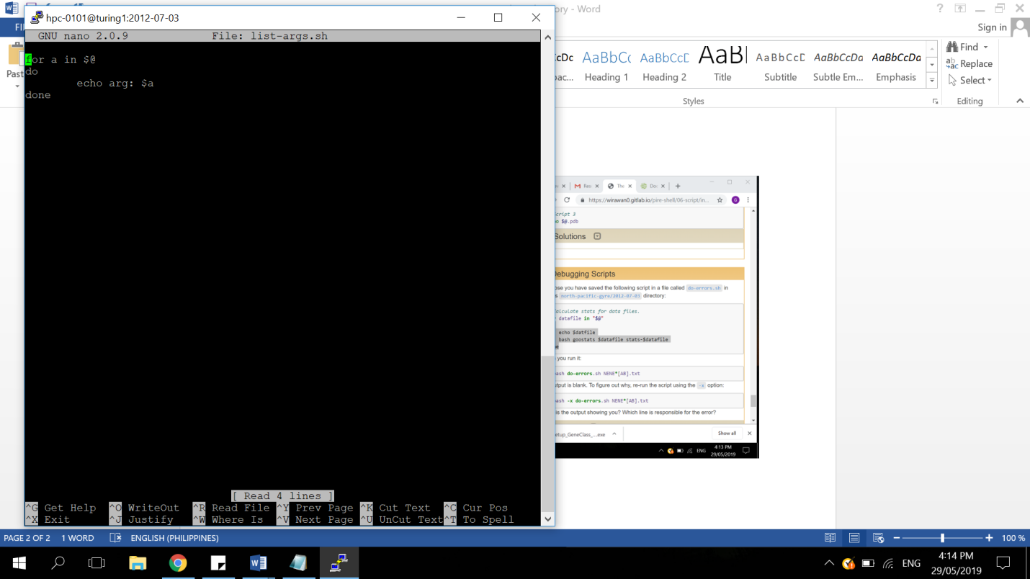

Making executable files

Syntax. Chmod

Example

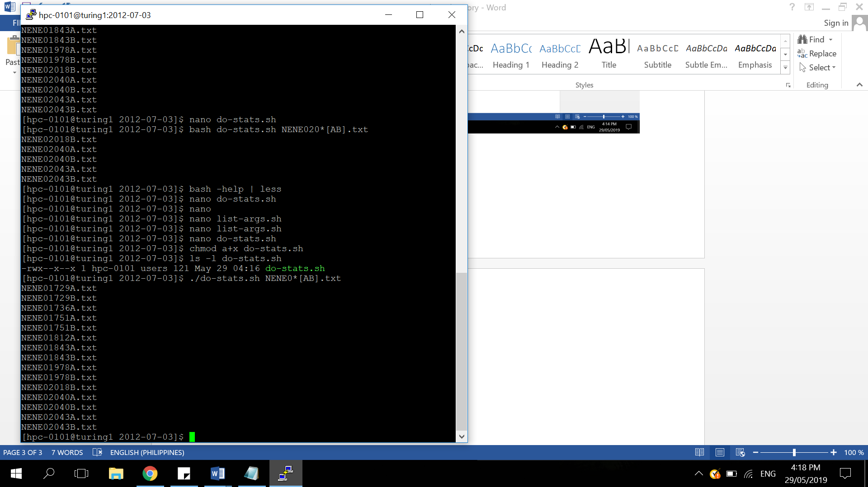

Running do-stats,sh on a the datasource(supercomputer) database

Syntax : sbatch

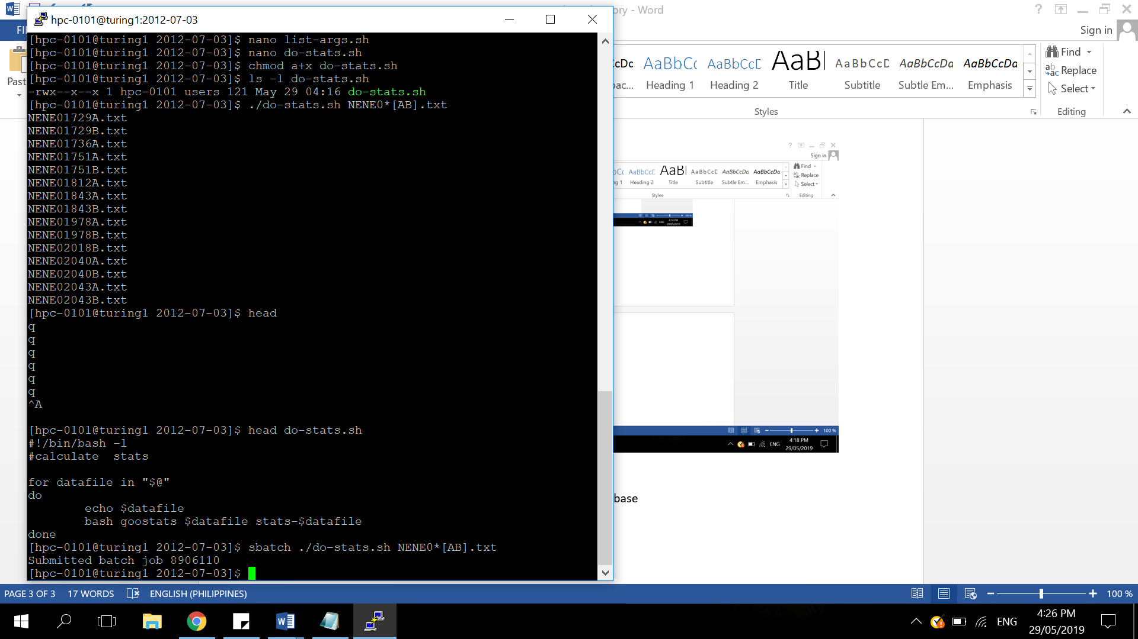

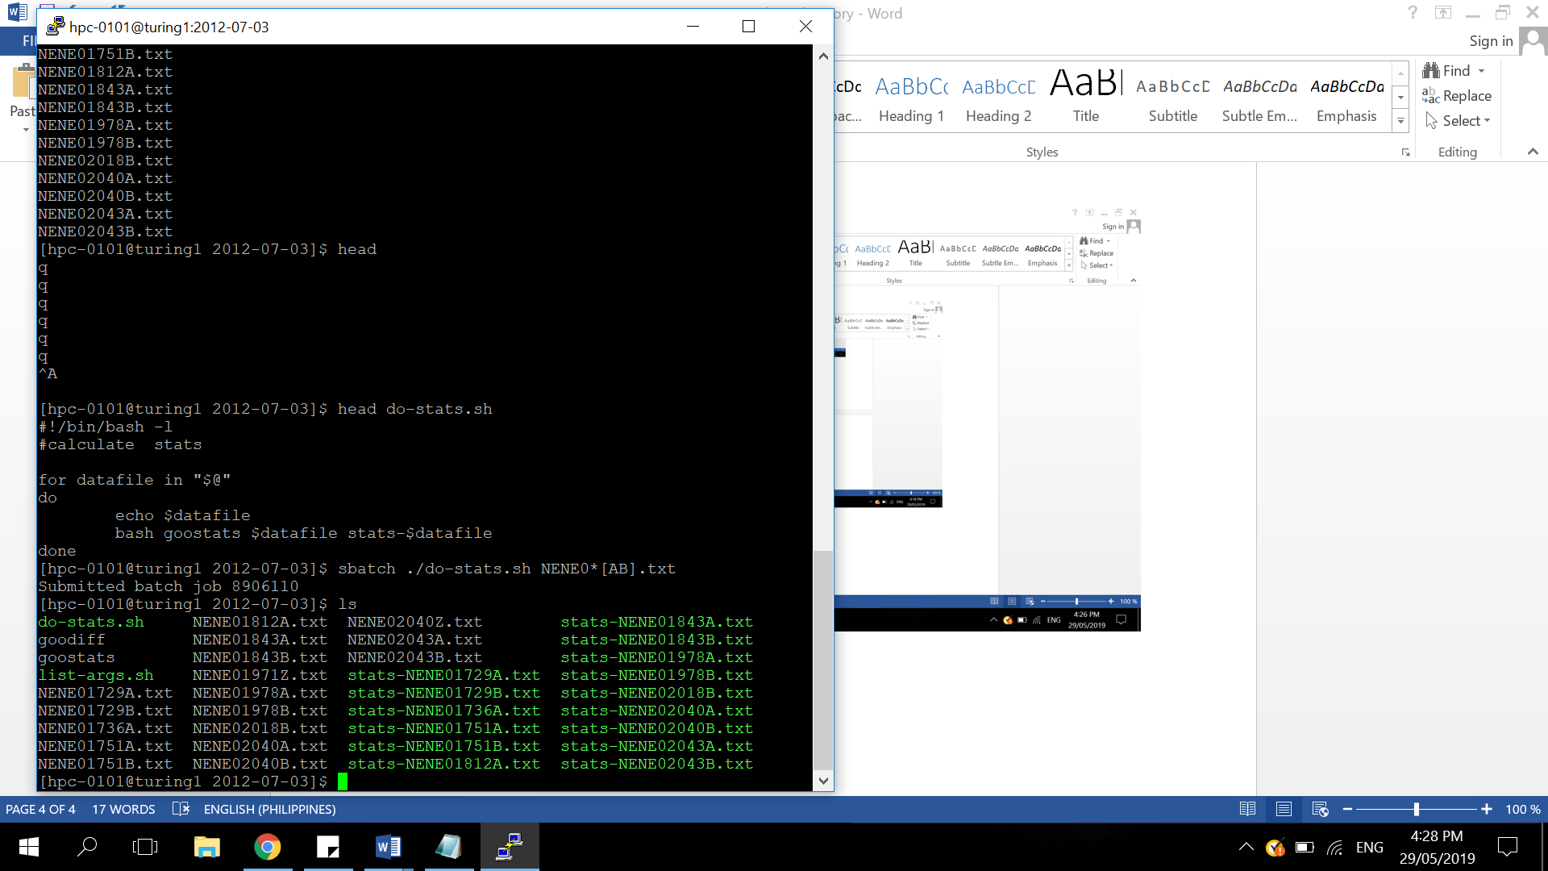

Making a New job name new_name, so the comm

Exercise:::

Create the top portion of a job script that will use 2 CPUs, 4 gigabytes of memory, and 5 minutes of walltime. (Note: if not specified, then only one node is requested.)

Solutions

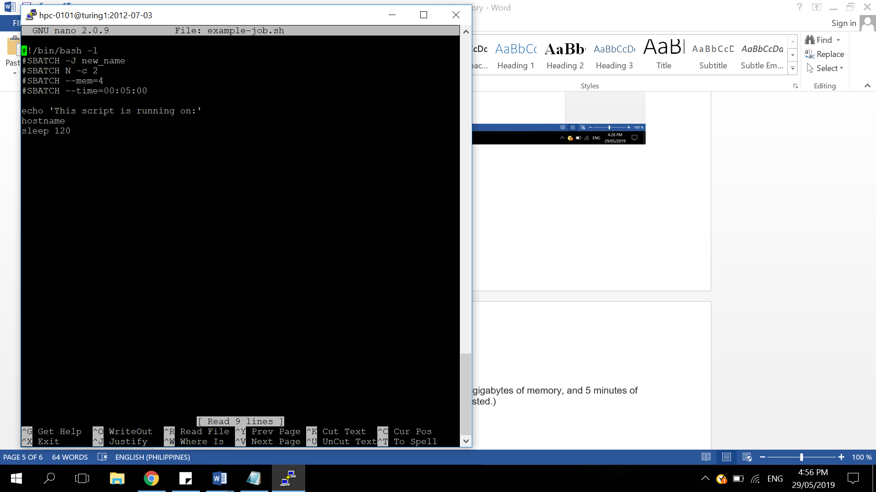

Canceling jobs

[yourUsername@turing1]$ scancel 38759

[yourUsername@turing1]$ squeue -u yourUsername

Scheduling jobs in HPC